Agung Rivalzo – 123190017

Praktikum SCPK – Tugas 6

SOURCE CODE

function varargout = SAW_Hotel(varargin)

% SAW_HOTEL MATLAB code for SAW_Hotel.fig

% SAW_HOTEL, by itself, creates a new SAW_HOTEL or raises the existing

% singleton*.

%

% H = SAW_HOTEL returns the handle to a new SAW_HOTEL or the handle to

% the existing singleton*.

%

% SAW_HOTEL('CALLBACK',hObject,eventData,handles,...) calls the local

% function named CALLBACK in SAW_HOTEL.M with the given input arguments.

%

% SAW_HOTEL('Property','Value',...) creates a new SAW_HOTEL or raises the

% existing singleton*. Starting from the left, property value pairs are

% applied to the GUI before SAW_Hotel_OpeningFcn gets called. An

% unrecognized property name or invalid value makes property application

% stop. All inputs are passed to SAW_Hotel_OpeningFcn via varargin.

%

% *See GUI Options on GUIDE's Tools menu. Choose "GUI allows only one

% instance to run (singleton)".

%

% See also: GUIDE, GUIDATA, GUIHANDLES

% Edit the above text to modify the response to help SAW_Hotel

% Last Modified by GUIDE v2.5 23-Jun-2021 22:54:23

% Begin initialization code - DO NOT EDIT

gui_Singleton = 1;

gui_State = struct('gui_Name', mfilename, ...

'gui_Singleton', gui_Singleton, ...

'gui_OpeningFcn', @SAW_Hotel_OpeningFcn, ...

'gui_OutputFcn', @SAW_Hotel_OutputFcn, ...

'gui_LayoutFcn', [] , ...

'gui_Callback', []);

if nargin && ischar(varargin{1})

gui_State.gui_Callback = str2func(varargin{1});

end

if nargout

[varargout{1:nargout}] = gui_mainfcn(gui_State, varargin{:});

else

gui_mainfcn(gui_State, varargin{:});

end

% End initialization code - DO NOT EDIT

% --- Executes just before SAW_Hotel is made visible.

function SAW_Hotel_OpeningFcn(hObject, eventdata, handles, varargin)

% This function has no output args, see OutputFcn.

% hObject handle to figure

% eventdata reserved - to be defined in a future version of MATLAB

% handles structure with handles and user data (see GUIDATA)

% varargin command line arguments to SAW_Hotel (see VARARGIN)

% Choose default command line output for SAW_Hotel

handles.output = hObject;

% Update handles structure

guidata(hObject, handles);

% UIWAIT makes SAW_Hotel wait for user response (see UIRESUME)

% uiwait(handles.figure1);

% --- Outputs from this function are returned to the command line.

function varargout = SAW_Hotel_OutputFcn(hObject, eventdata, handles)

% varargout cell array for returning output args (see VARARGOUT);

% hObject handle to figure

% eventdata reserved - to be defined in a future version of MATLAB

% handles structure with handles and user data (see GUIDATA)

% Get default command line output from handles structure

varargout{1} = handles.output;

% --- Executes on button press in pushbutton1.

function pushbutton1_Callback(hObject, eventdata, handles)

% hObject handle to pushbutton1 (see GCBO)

% eventdata reserved - to be defined in a future version of MATLAB

% handles structure with handles and user data (see GUIDATA)

[filename pathname]= uigetfile({'*.xlsx';},'buka_data'); %memanggil file berupa .xlsx

fullpathname = strcat(pathname, filename);

data = xlsread(fullpathname);

set(handles.edit2,'string',filename); %langsung mengambil nama file contoh trining.xlsx

set(handles.uitable1,'Data',data); %menampilkan data ke tabel

function edit2_Callback(hObject, eventdata, handles)

% hObject handle to edit2 (see GCBO)

% eventdata reserved - to be defined in a future version of MATLAB

% handles structure with handles and user data (see GUIDATA)

% Hints: get(hObject,'String') returns contents of edit2 as text

% str2double(get(hObject,'String')) returns contents of edit2 as a double

% --- Executes during object creation, after setting all properties.

function edit2_CreateFcn(hObject, eventdata, handles)

% hObject handle to edit2 (see GCBO)

% eventdata reserved - to be defined in a future version of MATLAB

% handles empty - handles not created until after all CreateFcns called

% Hint: edit controls usually have a white background on Windows.

% See ISPC and COMPUTER.

if ispc && isequal(get(hObject,'BackgroundColor'), get(0,'defaultUicontrolBackgroundColor'))

set(hObject,'BackgroundColor','white');

end

% --- Executes on button press in pushbutton2.

function pushbutton2_Callback(hObject, eventdata, handles)

% hObject handle to pushbutton2 (see GCBO)

% eventdata reserved - to be defined in a future version of MATLAB

% handles structure with handles and user data (see GUIDATA)

[filename pathname]= uigetfile({'*.xlsx';},'buka_data');

fullpathname = strcat(pathname, filename);

data = xlsread(fullpathname);

set(handles.edit3,'string',filename); %langsung mengambil nama file contoh trining.xlsx

set(handles.uitable2,'Data',data);

function edit3_Callback(hObject, eventdata, handles)

% hObject handle to edit3 (see GCBO)

% eventdata reserved - to be defined in a future version of MATLAB

% handles structure with handles and user data (see GUIDATA)

% Hints: get(hObject,'String') returns contents of edit3 as text

% str2double(get(hObject,'String')) returns contents of edit3 as a double

% --- Executes during object creation, after setting all properties.

function edit3_CreateFcn(hObject, eventdata, handles)

% hObject handle to edit3 (see GCBO)

% eventdata reserved - to be defined in a future version of MATLAB

% handles empty - handles not created until after all CreateFcns called

% Hint: edit controls usually have a white background on Windows.

% See ISPC and COMPUTER.

if ispc && isequal(get(hObject,'BackgroundColor'), get(0,'defaultUicontrolBackgroundColor'))

set(hObject,'BackgroundColor','white');

end

% --- Executes on button press in pushbutton3.

function pushbutton3_Callback(hObject, eventdata, handles)

% hObject handle to pushbutton3 (see GCBO)

% eventdata reserved - to be defined in a future version of MATLAB

% handles structure with handles and user data (see GUIDATA)

[filename pathname]= uigetfile({'*.xlsx';},'buka_data');

fullpathname = strcat(pathname, filename);

data = xlsread(fullpathname);

set(handles.edit4,'string',filename); %langsung mengambil nama file contoh trining.xlsx

set(handles.uitable3,'Data',data);

function edit4_Callback(hObject, eventdata, handles)

% hObject handle to edit4 (see GCBO)

% eventdata reserved - to be defined in a future version of MATLAB

% handles structure with handles and user data (see GUIDATA)

% Hints: get(hObject,'String') returns contents of edit4 as text

% str2double(get(hObject,'String')) returns contents of edit4 as a double

% --- Executes during object creation, after setting all properties.

function edit4_CreateFcn(hObject, eventdata, handles)

% hObject handle to edit4 (see GCBO)

% eventdata reserved - to be defined in a future version of MATLAB

% handles empty - handles not created until after all CreateFcns called

% Hint: edit controls usually have a white background on Windows.

% See ISPC and COMPUTER.

if ispc && isequal(get(hObject,'BackgroundColor'), get(0,'defaultUicontrolBackgroundColor'))

set(hObject,'BackgroundColor','white');

end

% --- Executes on button press in pushbutton4.

function pushbutton4_Callback(hObject, eventdata, handles)

% hObject handle to pushbutton4 (see GCBO)

% eventdata reserved - to be defined in a future version of MATLAB

% handles structure with handles and user data (see GUIDATA)

x = xlsread(get(handles.edit2,'string'));

k = xlsread(get(handles.edit3,'string'));

[m n]=size (x); %matriks m x n dengan ukuran sebanyak variabel x (input)

R=zeros (m,n); %membuat matriks R, yang merupakan matriks kosong

Y=zeros (m,n); %membuat matriks Y, yang merupakan titik kosong

for j=1:n,

if k(j)==1, %statement untuk kriteria dengan atribut keuntungan

R(:,j)=x(:,j)./max(x(:,j));

else

R(:,j)=min(x(:,j))./x(:,j);

end;

set(handles.uitable4,'Data',R);

end;

w = xlsread(get(handles.edit4,'string'));

for i=1:m,

V(i)= sum(w.*R(i,:))

set(handles.uitable5,'Data',V);

[nilai,urut]=max(V)

set(handles.edit6,'string',(nilai));

set(handles.edit5,'string',(urut));

end;

% --- Executes on button press in pushbutton5.

function pushbutton5_Callback(hObject, eventdata, handles)

% hObject handle to pushbutton5 (see GCBO)

% eventdata reserved - to be defined in a future version of MATLAB

% handles structure with handles and user data (see GUIDATA)

set(handles.edit2,'string',''); %menghapus nilai pada text4

set(handles.edit3,'string','');

set(handles.edit4,'string','');

set(handles.edit5,'string','');

set(handles.edit6,'string','');

set(handles.uitable1, 'Data', {})

set(handles.uitable3, 'Data', {})

set(handles.uitable2, 'Data', {})

set(handles.uitable4, 'Data', {})

set(handles.uitable5, 'Data', {})

function edit5_Callback(hObject, eventdata, handles)

% hObject handle to edit5 (see GCBO)

% eventdata reserved - to be defined in a future version of MATLAB

% handles structure with handles and user data (see GUIDATA)

% Hints: get(hObject,'String') returns contents of edit5 as text

% str2double(get(hObject,'String')) returns contents of edit5 as a double

% --- Executes during object creation, after setting all properties.

function edit5_CreateFcn(hObject, eventdata, handles)

% hObject handle to edit5 (see GCBO)

% eventdata reserved - to be defined in a future version of MATLAB

% handles empty - handles not created until after all CreateFcns called

% Hint: edit controls usually have a white background on Windows.

% See ISPC and COMPUTER.

if ispc && isequal(get(hObject,'BackgroundColor'), get(0,'defaultUicontrolBackgroundColor'))

set(hObject,'BackgroundColor','white');

end

function edit6_Callback(hObject, eventdata, handles)

% hObject handle to edit6 (see GCBO)

% eventdata reserved - to be defined in a future version of MATLAB

% handles structure with handles and user data (see GUIDATA)

% Hints: get(hObject,'String') returns contents of edit6 as text

% str2double(get(hObject,'String')) returns contents of edit6 as a double

% --- Executes during object creation, after setting all properties.

function edit6_CreateFcn(hObject, eventdata, handles)

% hObject handle to edit6 (see GCBO)

% eventdata reserved - to be defined in a future version of MATLAB

% handles empty - handles not created until after all CreateFcns called

% Hint: edit controls usually have a white background on Windows.

% See ISPC and COMPUTER.

if ispc && isequal(get(hObject,'BackgroundColor'), get(0,'defaultUicontrolBackgroundColor'))

set(hObject,'BackgroundColor','white');

end

GUI

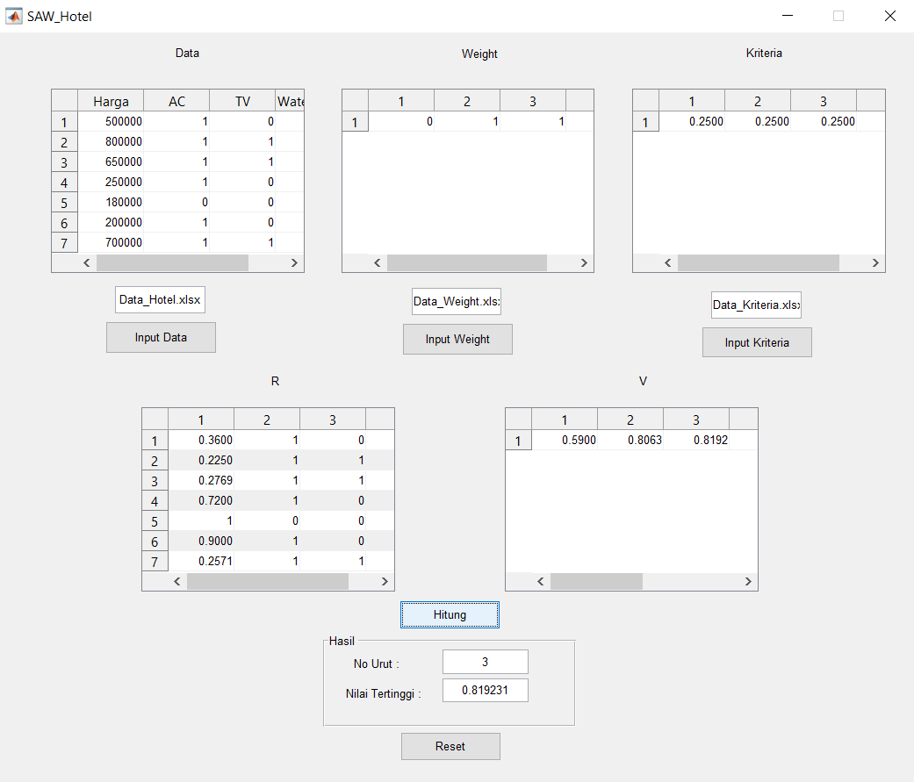

Pembahasan Hasil

Berdasarkan hasil perhitungan data yang terdapat dalam tabel, dihasilkan penilaian sebagai berikut :

Yaitu hotel dengan no urut 3 dengan nilai 0.819231